Inspection Pending, Multiple Delivery Locations Features & Stock Report

Inspection Pending (Out of Stock)
Overview:
In the context of out of stock items, the Pending Inspection Report will be more granular, allowing different teams (based on their warehouse) to view, track, and take action on inspections pending for out-of-stock materials.
Inspection Completion Stage:
In the inspection stage, users will have the option to complete the inspection for each material individually or in bulk.
- Individual Completion:
Users can select a single item or multiple items and mark it as inspected. This option allows for more detailed tracking and manual verification for each material.
- Bulk Completion:
As is currently available, users will be able complete the inspection for all materials at once. This option is ideal for handling large volumes of items at once, improving efficiency.
Report for Warehouse-Based Visibility:
- Warehouse-Specific Pending Inspection Report:
  - The report will be filtered and organized by warehouse, providing clear visibility to the team members responsible for each location.
  - Each warehouse will have its own set of out-of-stock materials pending inspection, allowing teams to focus on their specific area and increase operational efficiency.
- Report Filters:
  - Users will be able to filter the report by warehouse, ensuring that they only see the relevant pending items for inspection that pertain to their specific location.
- Tracking by Days Pending:
  - Materials will be tracked based on how many days they have been pending for inspection.
  - Red Flagging by Warehouse: If an item has been pending for more than 2 days, it will be flagged in red to draw attention for immediate action.
- Warehouse-Specific Responsibilities:
  - Warehouse teams will be able to directly manage the items in their warehouse by checking their report, ensuring that pending inspections are handled in a timely manner.

- Dashboard Integration:
  - A dashboard view will provide quick access to performance data regarding pending inspections across multiple warehouses.
  - Dashboard Header to include:
    - Warehouse Name
    - Number of pending inspections by warehouse
    - Number of items overdue (red-flagged) by warehouse
    - Average days pending per warehouse
  - Detailed Reports could include:
    - Order Number
    - Return Delivery Number (hyperlinked to inspection within the rental process)
    - Item ID
    - Item Name
    - Contract End Date
    - Check In Date
    - Days Overdue (flagged red if overdue)
    - Notes
    - Action Button (complete inspection or do stock adjustment)
User Interface (UI) Updates for Warehouse Visibility:
- Report Page for Pending Inspections:
  - Users can select a warehouse from a dropdown or filter bar at the top of the report page.
  - Once a warehouse is selected, the data will be filtered to show only the relevant pending inspection items.
- Color Coding and Alerts by Location:
  - The red flagging of overdue inspections will be visually represented with different color highlights by location, making it easy to identify which warehouse has the most pressing issues.
- Location-Specific Notifications:
  - Reminder notifications for pending inspections will be sent daily, ensuring the right teams are notified about pending inspections in their area. These reminders will be triggered based on the location’s due dates.

Report Access:
- User Feedback:
  - Users will be able to add comments or notes related to pending inspections, which can be reviewed by warehouse managers. This ensures that any additional context (e.g., inspection delays) is captured and tracked, improving communication and transparency.
- Warehouse Base Access:
  - New role for warehouse pending inspection report to be created.
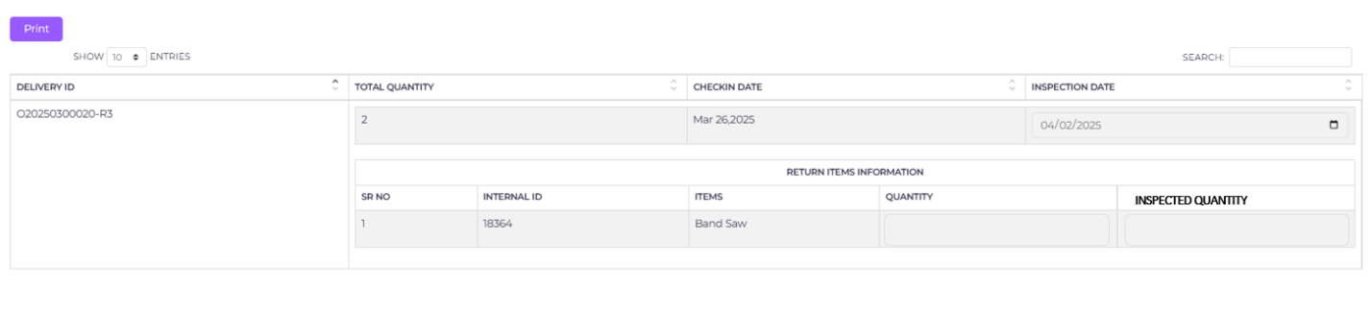

Multiple Delivery Locations
Overview:
The Multiple Delivery Locations feature will allow the user to specify multiple delivery locations for both delivery and return processes. This will streamline logistics and improve the delivery experience for customers with multiple locations.

Key Components:
- Multiple Deliveries for Different Locations:
  - Option 1 – Multiple Deliveries:
The user can create multiple deliveries, each with a different delivery address, within the selected range or customer location.
  - Option 2 – Single Delivery with Multiple Locations:
As an alternative, the user can select multiple locations during the creation of a single delivery. This option simplifies the process by avoiding multiple entries and allowing all locations to be grouped under one delivery record.
- Return Delivery Integration:
  - The selected multiple locations during the delivery creation process will also be reflected in the return delivery process. This ensures consistency and accurate tracking throughout the entire rental period.
- Free Text Notes for Each Location:
  - Customizable Notes:
For each location added, the user will have the option to add free text notes. These notes will allow for detailed instructions, comments, or specific delivery conditions such as quantity adjustments or special handling requirements for each location.
  - Use Case:
This feature can be used to specify unique handling requirements for each location, such as delivery quantities, delivery time preferences, or special instructions for handling the items.
- Delivery Address and Notes Display:
  - The delivery address and the free text notes for each location will be clearly displayed at the bottom of the table of each delivery within stage 1 & 5 of the rental process.
  - Visibility:
This ensures that the user can see the details for each delivery, including the associated location notes, at any stage of the rental process, making it easy to track all relevant delivery and return information.
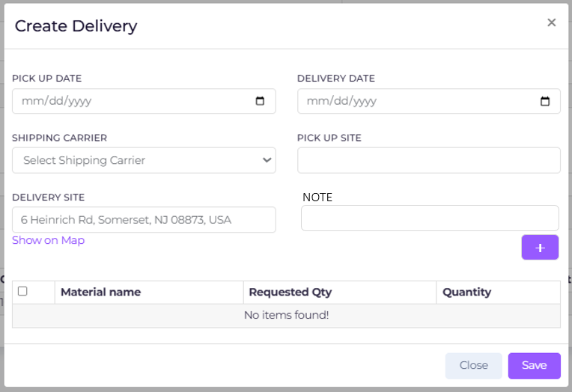
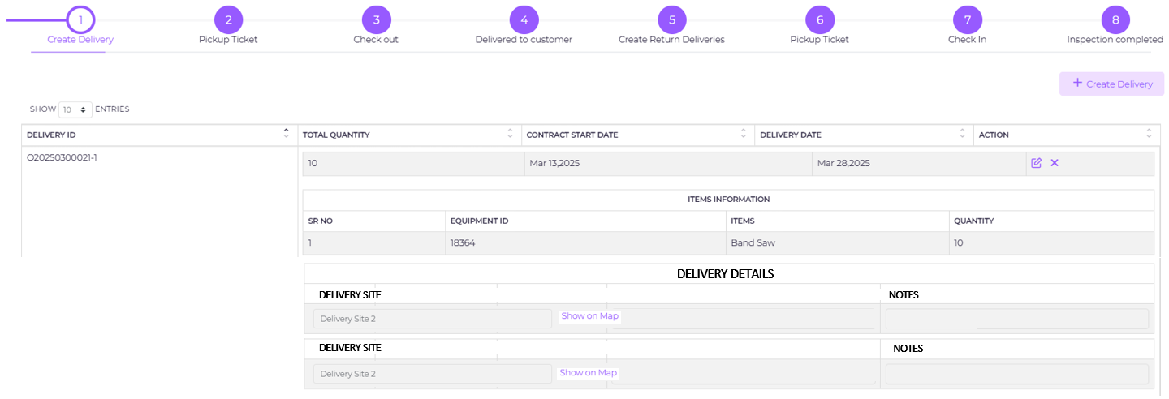

Stock Reports

Status Definitions:
- In Transit:
  - Definition: Stocks that are either on their way to a customer or being returned from a customer to the warehouse.
  - Condition: Items that have been picked up from the warehouse but not yet delivered to the customer or have been picked up from the customer but not yet returned or delivered to another location.
  - Location: This status will not require a location update since the item is in transit.
- On Rent:
  - Definition: Stocks that have been delivered to a customer and are still within the contract rental period.
  - Condition: Items that are with the customer and the rental period has not yet ended.
  - Location: Customer Name & Location (Delivery Location) will be filled out since the stock is with the customer.
- Pending Inspection:
  - Definition: Items that have been checked back into the warehouse but have not yet completed the inspection process.
  - Condition: Items in the warehouse awaiting inspection confirmation but still in the pending stage.
  - Location: Warehouse Location will be filled in since the item is within the warehouse but still pending inspection.
- Off Rent Onsite:
  - Definition: Stocks that have been delivered to the customer but are after the contract end date.
  - Condition: Items that are at the customer’s location post-rental period and are no longer under rental agreement.
  - Location: Customer Name & Location (Delivery Location) will be filled out since the item is at the customer’s location.
- Rent Ready:
  - Definition: Stocks that are available in the warehouse, not rented, not in transit, and not pending inspection or off rent.
  - Condition: Items that are available and ready to be rented but are not part of any ongoing rental agreements.
  - Location: Warehouse Location will be filled in, as these stocks are in the warehouse and available for rent.

Stock Report Structure:
The stock report can now include these new statuses and locations based on the status of each item. Here’s a breakdown of the adjustments:
- Columns to Include:
  - Date: The date the entry was recorded.
  - Equipment ID: The unique ID for the equipment.
  - Equipment Name: The name or description of the equipment.
  - Location: Consolidated location field, which can represent either the Warehouse Location or Customer Delivery Location, depending on the status.
  - Quantity: The quantity of the equipment in the status.
  - Status: The current status of the stock (In Transit, Rent Ready, On Rent, Pending Inspection, Off Rent Onsite).
  - Days in Status: A calculated field that tracks the number of days the stock has been in its current status.
- Location Column: The Location field should dynamically update based on the stock’s status:
  - For Rent Ready and Pending Inspection, the location should be the Warehouse Location.
  - For On Rent and Off Rent Onsite, the location should be the Customer Name & Location (Delivery Location).
- Status Column: This column will reflect one of the five statuses (In Transit, Rent Ready, On Rent, Pending Inspection, Off Rent Onsite).

Report Filters:
- By Equipment Name
- By Date
- By Status
- By Location

